VAISHNAVI-23PA1A0572
Salesforce Developer Bridge Program
Day 2 – Self Learning Track
Project Name
Hospital OPD Management System
Platform
Salesforce CRM

Introduction
The objective of Day 2 was to improve Apex programming skills by learning Apex Collections, Governor Limits, Bulkification, Asynchronous Apex, and Lightning Web Components (LWC). All the tasks were implemented using the Hospital OPD Management System created on Day 1.

Objectives
- Learn Apex Collections (List, Set, and Map).
- Understand Governor Limits.
- Learn Bulkification.
- Implement Future Methods.
- Build Lightning Web Components.
- Follow Salesforce best practices.

Project Overview
The Hospital OPD Management System is a Salesforce application used to manage hospital outpatient records.
Custom Objects
- Patient
- Doctor
- Appointment
- Prescription
Relationships
- Patient → Appointment (Lookup)
- Doctor → Appointment (Lookup)
- Appointment → Prescription (Master-Detail)

Task 1 – Apex Collections
List Collection
A List was used to retrieve all Doctor records from Salesforce and display their names using a for loop.
Output: Successfully displayed all Doctor records.
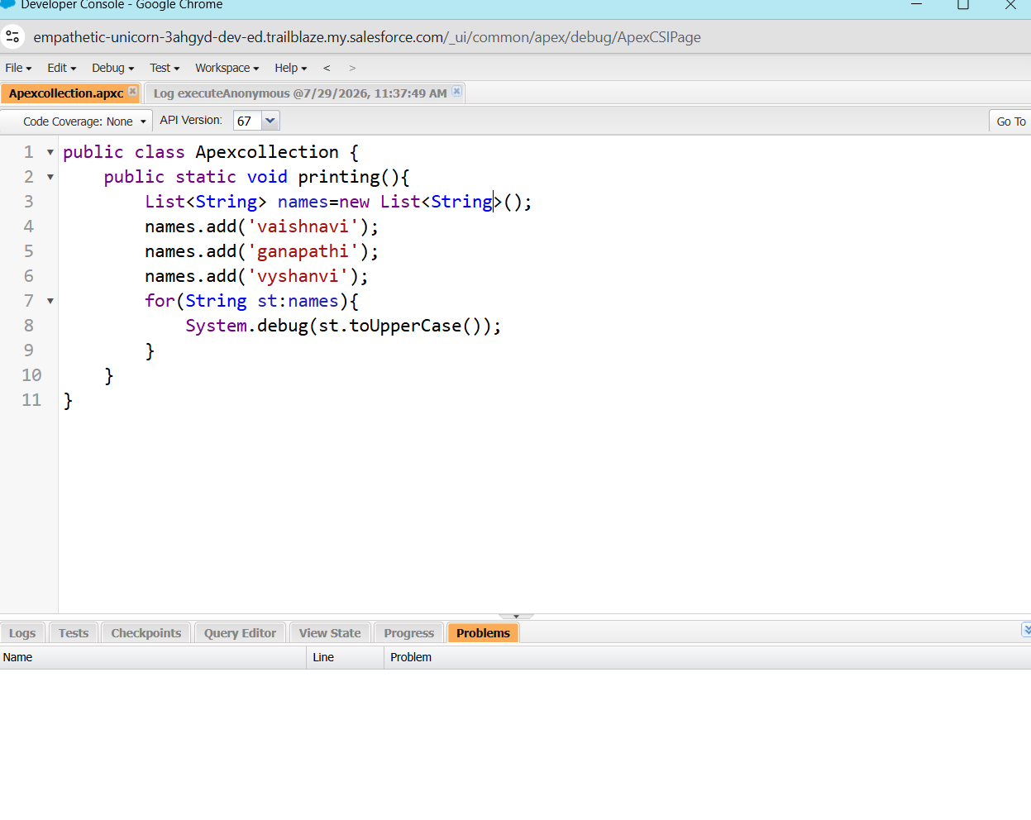

Set Collection
A Set was used to store unique Patient record IDs and display the total number of records.
Output: Successfully displayed the unique record count.
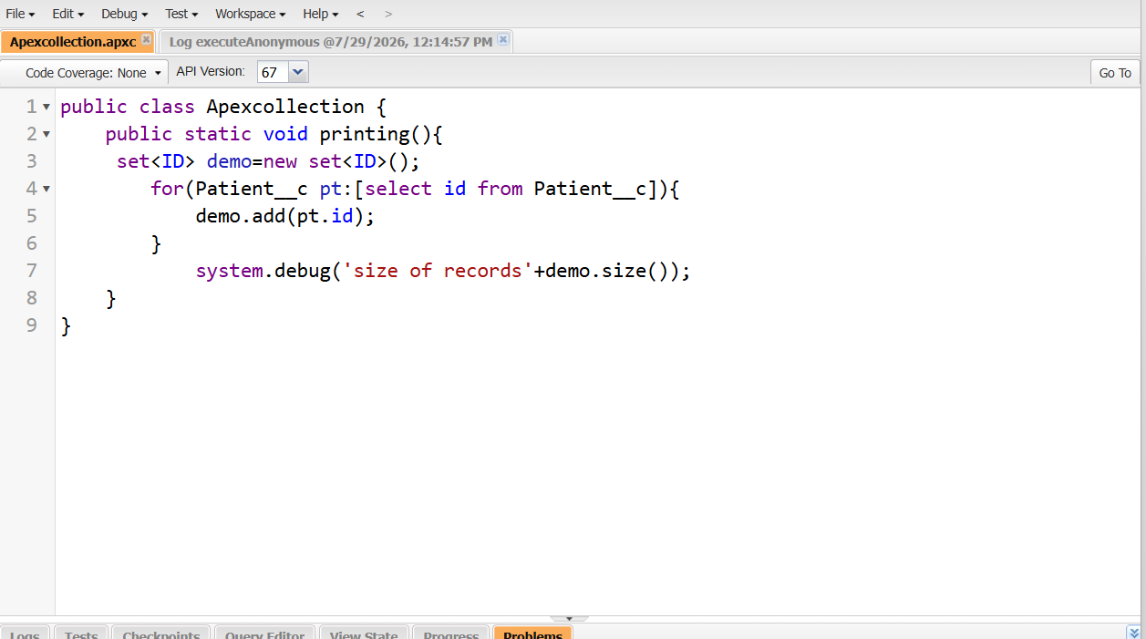

Map Collection
A Map was created using Patient records. The Patient Id was used as the key, and the Patient record as the value. A record was retrieved using its Id and displayed successfully.
Output: Successfully retrieved and displayed the Patient Name.
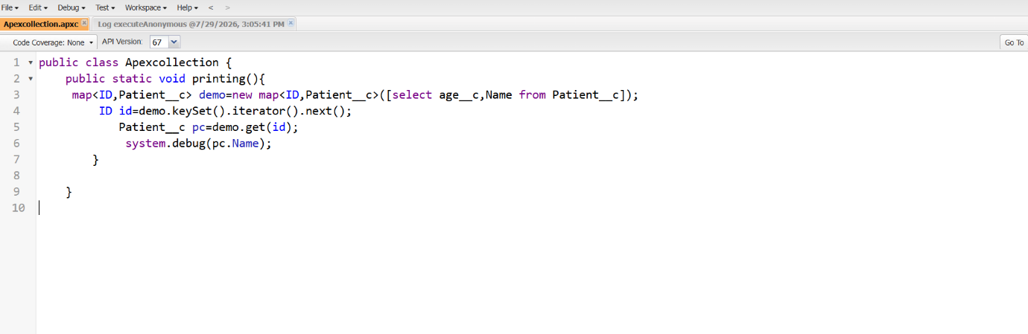

Task 2 – Governor Limits
A SOQL query was intentionally written inside a loop to understand Salesforce Governor Limits. After processing 200 Doctor records, the system generated the error:
System.LimitException: Too many SOQL queries: 101
This demonstrated why SOQL should not be written inside loops.
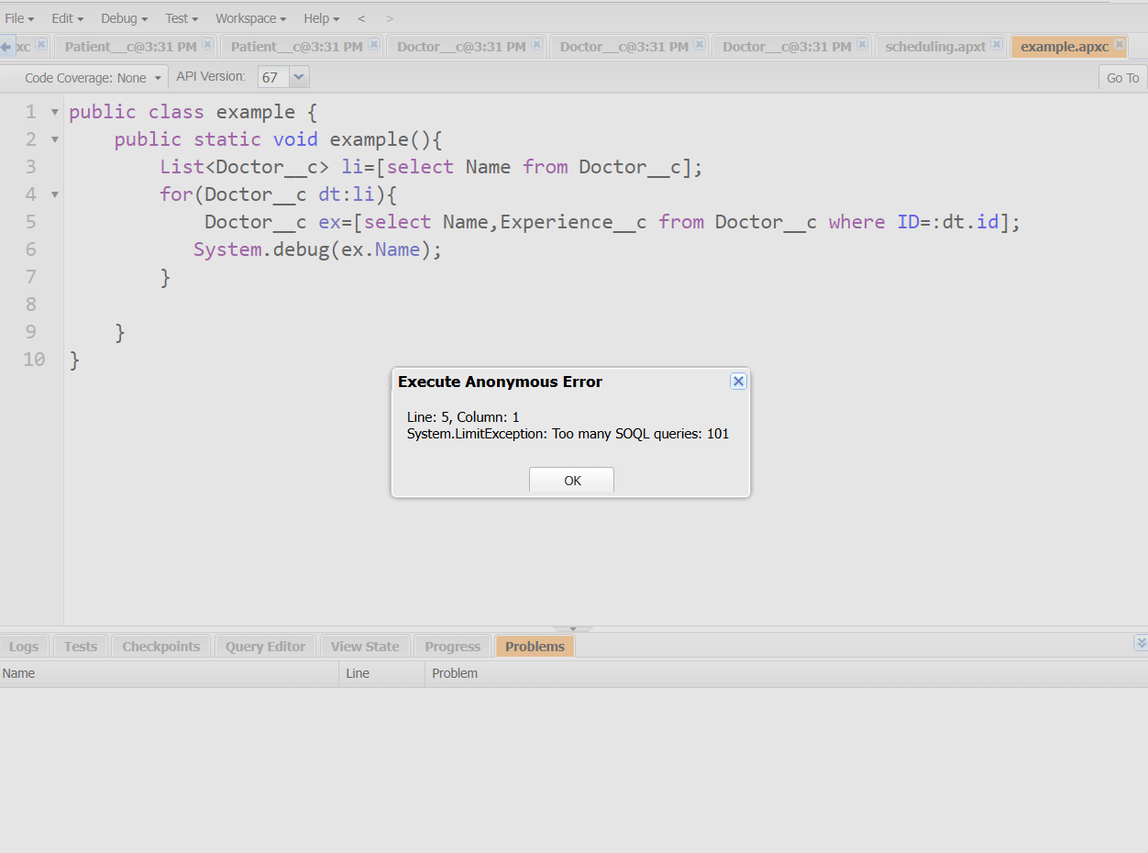
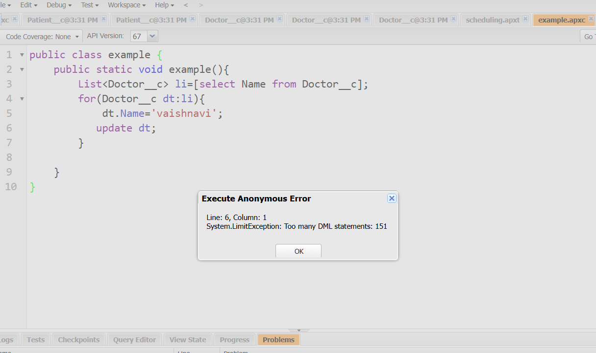

Task 3 – Bulkification
The SOQL query was moved outside the loop to optimize the code.
Result
- No Governor Limit exception occurred.
- All records were processed successfully.
- Performance improved by reducing SOQL queries.
- 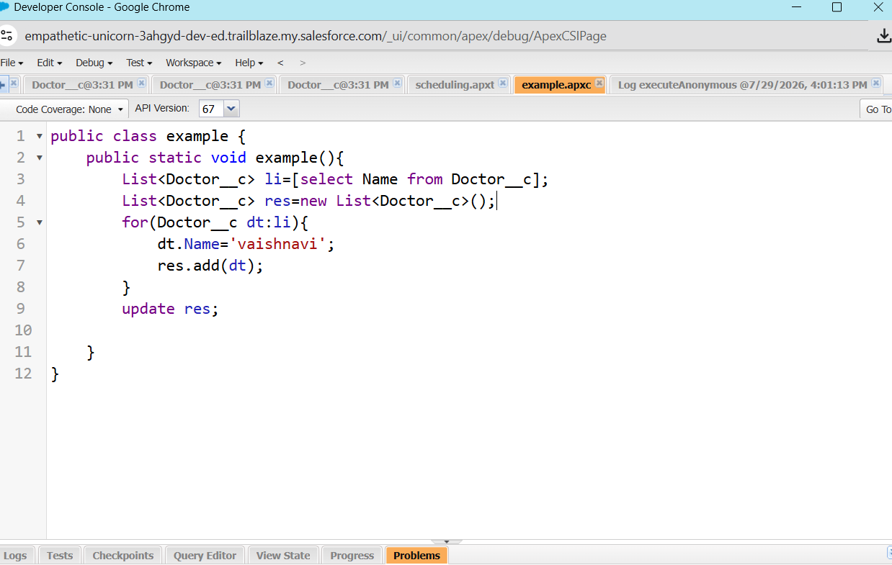

Task 4 – Asynchronous Apex
A Future Method was created to update a Patient record asynchronously. The method was executed from Execute Anonymous, and the job was verified in Apex Jobs.
Result: The record was updated successfully in the background

Task 5 – Lightning Web Components
Two Lightning Web Components were created.
Parent to Child
The Parent Component passed the Record Id to the Child Component using the @api decorator.
Child to Parent
The Child Component fired a Custom Event, and the Parent Component updated the UI after receiving the event.
Result: Communication between components was successful.

Learning Outcomes
After completing Day 2, I learned:
- Apex Collections (List, Set, and Map)
- SOQL optimization
- Governor Limits
- Bulkification
- Future Methods
- LWC Component Communication
- Salesforce coding best practices

